PHYSICS II
Chapter 25
Electromagnetic Waves, Nature of Light & Doppler Effect

Having Trouble? Come to our weekly workshops and get ahead! Workshops are $20 each and last 1-2 hours. All the workshops are recorded and available for viewing on demand during our normal business hours.
Need Help All Semester? Register for the Semester Plan which includes all workshops, exam reviews, final exam lab review and office hours. The Semester Plan price is only $200 for the whole semester.

Current Course Offerings at Science Guyz:
- General Chemistry 1 - CHEM 1211
- General Chemistry 2 - CHEM 1212
- Physics 1 – PHYS 1111
- Physics 2 – PHYS 1112
- Organic Chemistry 1 - CHEM 2211
- Organic Chemistry 2 - CHEM 2212
- Biology 1 – BIOL 1107

Spring 2020

For hours of operation, important dates and other info, check our regularly updated website:
www.scienceguyz.com

Chapter 25 – Electromagnetic Waves

Speed of Light
How is speed calculated?
$$speed=\frac{distance }{time}$$

Nothing travels faster than the speed of light but not all light is visible. In a vacuum, all light travels at $3.00×{10}^{8}m/s$ or more generally denoted at $c$.

Light Spectrum
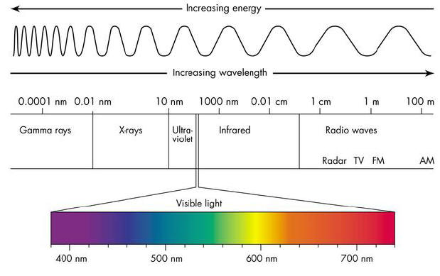
We can use this relationship to determine how far away an object is.Light is categorized by their respective wavelengths as shown in the figure below:

STUDY TIP:
Typically, you are not expected to memorize the frequencies or wavelengths of all types of light but you are expected to know that the range of visible light is $400 nm$ (violet) to $700 nm$ (red).
Example: Suppose NASA has a satellite in orbit around Saturn. Given that it takes about 72.7 minutes for the data from the satellite to reach the command center, approximately how far is Saturn from Earth?

Additional Practice: If ground control wants to send radio signals to a satellite that is orbiting a planet $4.50×{10}^{12}$ meters away, how long will it take the signal to reach its destination?

Frequency and Wavelength
Since light acts like a wave, it adheres to wave-like properties. It has a wavelength, $λ$ and frequency, $f$. The two properties are related by the following:

$$c=fλ$$

$c$ remains constant so what happens as $f$ changes?

Example: How many green wavelengths ($λ=540 nm$) long is a 50.5 ft yacht?

Additional Practice: WSB AM 750 in Atlanta operates at 1030 kHz.
- What is the corresponding wavelength for this frequency?

- Its FM sister station is 95.5, which operates at 107.5 MHz. What is its wavelength?

Additional Practice: In order for a telescope to operate effectively, any imperfections on its reflective surface must be no more than one-tenth the size of the wavelength for which the telescope is designed. If a telescope is manufactured to detect radio waves of frequency $6.22×{10}^{7}$Hz, what is the maximum acceptable size of an imperfection?

Additional Practice: What is the frequency of red light with a wavelength of $713 nm$?

Doppler Effect
The Doppler Effect for light waves is not much different from sound waves and can be expressed by the following equation:
$$f_{det}=f_{emit}\left(1±\frac{u}{c}\right)$$
Where $f_{det}$ is the frequency observed and $f_{emit}$ is the frequency emitted from the source. $u$ represents the relative speed between the observer and the source and $c$ is the speed of light. $c=3×{10}^{8}m/s$

When the observer and the source are approaching each other, use the positive case. An observer would perceive a frequency.

When the observer and the source are moving away from each other, use the negative case. An observer would perceive a frequency.

Example: A spaceship is traveling directly toward the Earth with a speed of $33,350 km/s$, sending signals along the way.
- When the wavelengths of the ship’s signal are measured on Earth, are they greater or less than the wavelengths we would find if the spaceship were at rest relative to us?

- By what fraction are the signal’s wavelengths shifted?

Additional Practice: Radar detectors use light rays to function. Suppose your radar gun operates at a frequency of 9.01 GHz.
- While standing on the side of the road, your friend approaches at 32.6 m/s and you clock him with your gun. What frequency shift will the outgoing wave experience?

- Once the wave reflects off of your friends car and bounces back, the radar gun measures the overall frequency shift. By what percentage is the final measured frequency different from the original emitted frequency?
Additional Practice: When running late for a meeting, you approach a red light. In a fit of genius, you decide to accelerate your car to a speed such that the light changes from red (682 nm) to yellow (589 nm).
- How fast would you have to travel in mi/hr to achieve this feat?

- If you had been traveling that fast and the light actually was yellow, what color would it have seemed to you?

