CHEM 2211
Chapter 2: Acids and Bases
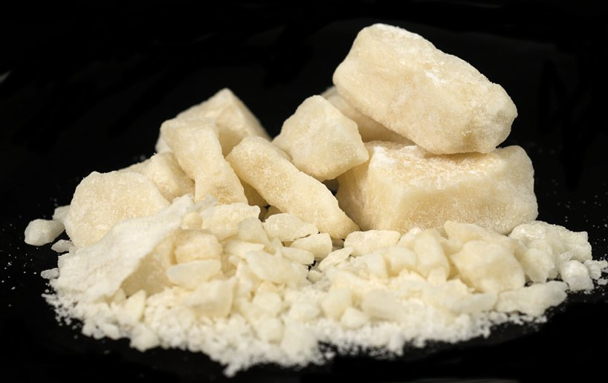

Crack-Cocaine, It Does a Body Bad!

Having Trouble? Come to our weekly workshops and get ahead! Workshops are $20 each and last approximately 2 hours. Private tutoring is also available by appointment on our website, www.scienceguyz.com.

Need Help All Semester? Register for the Semester Plan which includes 10 Workshops, 5 Exam Reviews Sessions, 5 Mock Exams, a lab review session, and daily Office Hours. The Semester Plan price is only $250 for the entire semester.

Spring 2019

For hours of operation, important dates and other info, check our regularly updated website:
www.scienceguyz.com
- Introduction: Acid/Base chemistry is pervasive in most biological processes. From the medicines we take to cure ailments, to the simple act of breathing, acid/base chemistry is a necessary part in all forms of life.
- The Difference Between Crack and Cocaine: By the end of this workshop, you should be able to:
  - Describe the physical difference between crack and cocaine.
  - Describe a method for converting crack to cocaine and vice-versa.
  - Describe why cocaine is snorted while crack is smoked.
  - Complete all of the chapter 2 in-chapter and end-of-chapter problems.
Classifications of Acids and Bases
- Bronsted Acids and Bases
  - Bronsted Acids: Bronsted acids are proton (hydrogen with no electrons) donors.
  - Bronsted Bases: Bronsted bases are proton acceptors.
- Lewis Acids: Lewis acids are electron acceptors (usually group III elements which make three bonds or transition metals).
  - Lewis Bases: Lewis Bases are electron donors.
  - Uncommon Lewis Acids: TiCl₄, FeBr₃, SnCl₂, AlCl_{3,} and BF₃. Remember than any of the halogens used in the list above can be exchanged with other halogens.
    - Other uncommon Lewis acids are any compound containing a Group III element which is making three bonds.
Acid Base Reactions
- Completing Acid Base Reactions:
  - First, determine which species is the acid and which species is the base:
    - Always Acids: Strong Acids and uncommon Lewis acids will always be acids: HCl, HBr, HI, HNO₃, H₂SO₄, H₃PO₄, TiCl₄, SnCl₂, FeBr₃ etc…
    - Always Bases: Any time an alkali or an alkali earth metal is attached to a non-metal, this species will always be the base: NaCl, KOH, BrMgCH₃ etc…
  - Second, identify where the acidic proton on the acid is:
    - The acidic proton will generally be the proton attached to the most electronegative atom.
  - Third, identify the basic lone pair of electrons:
    - The basic lone pair of electrons will generally be those electrons present on the least electronegative atom in the basic compound.
  - Finally, complete the acid base reaction:
    - The acid (Bronsted) will give up proton (H⁺) and leave behind a lone pair of electrons (Becomes the Conjugate Base).
    - The base (Bronsted) will accept a proton (H⁺) using its lone pair of electrons (Becomes the Conjugate Acid).
  - Remember that alkali and alkali earth metals which are bound to non-metals represent ionic bonds and will dissociate in solution to form ions. Also, be mindful of how the formal charge of an atom changes when it gains or loses electrons.
- Curved arrows in Bronsted-Lowery acid/base reactions:
  - First, draw a double-headed arrow from the lone pair of electrons on the base to the acidic proton.
  - Second, draw a double-headed arrow from the bond connecting the acidic proton to the acid; to the atom that the acidic proton was attached to.
- Curved arrows in Lewis acid/base reactions:
  - Draw a double-headed arrow from the lone pair of electrons on the base to the group III element or the transition metal of the Lewis acid (be mindful of bases which dissociate).

Pause the video and complete the concept check by drawing in the curved arrows which will complete the acid base reactions below.
Determining whether the acid/base equilibrium favors the products or the reactants using pKa.
- pKa: Tells which side of an acid base equilibrium will be favored (you will be given a chart similar to the one shown below, for determining pKa values).
  - When assessing an acid and a base which are on the same side of the equilibrium equation:
    - If the base has a higher pKa than the acid, the opposite side of the reaction will be favored.
    - If the acid has a higher pKa than the base, the side of the reaction that you are assessing will be favored.
  - When assessing an acid and a conjugate acid or a base and a conjugate base which appear on the opposite sides of the equilibrium equation.
    - When assessing an acid and a conjugate acid, the side of the equilibrium which has the weakest acid (higher pKa) will be favored.
    - When assessing and base and a conjugate base the weaker base (lower pKa) will be favored.

Example: Circle which acid is the NaOH (pKa = 15.0) strong enough to deprotonate?
What’s Crack Got to do with Cocaine?: Converting crack to cocaine (and vice versa) is a simple acid-base reaction.
Why Crack is Smoked and Cocaine is Snorted:
- Crack: Crack is smoked because it is a neutral compound which is insoluble in water. Crack’s insolubility prevents it from readily being absorbed through the membranes in the nose. In order to ingest crack, crack must be heated into the gas phase where it can enter the bloodstream through inhalation.
- Cocaine: Cocaine is snorted because it is an ionic compound which is readily soluble in water. Due to its solubility in water, cocaine can be absorbed through the membranes in the nose and can readily enter the bloodstream through this vehicle.
“Crack is Whack, Crack is Cheap, I make too much Money to Smoke Crack” (Whitney Houston) Legal Consequences of Possessing Crack Versus Cocaine Prior to 2010:
- The Fair Sentencing Act: Prior to August 3, 2010 there was a 5-year mandatory federal sentence for a person in possession of 5-grams of crack while the possession of a staggering 500-grams of cocaine would be required to trigger the same sentence.
- Reasoning Behind Disparity in Sentencing: Research showed that more violent crimes were committed over crack as opposed to cocaine. To thwart the violence, the sentencing for possession of crack was increased.
- Research Dispels the Efficacy of Sentencing: Research showed that the disparate sentencing ultimately didn’t have an effect on violence. However, the sentencing disproportionally, incarcerated the poor and persons of color for longer periods of time (all of this over a simple proton, the smallest atom on the periodic chart).
Acidity Trends: In General, the acidity of a proton in an acid will depend on one of three things for Bronsted-Lowery acids:
- When comparing acidic protons which are on different atoms, the more acidic compound will depend on either electronegativity or size.
  - Electronegativity: Always look to electronegativity when comparing atoms in the same period. When comparing a series of acids which have their most acidic proton attached to atoms which are in the same period of the periodic chart, the more electronegative the atom which bears the acidic proton, the more acidic the acid.
  - Size: Always look to atomic radii when comparing atoms in the same group. When comparing a series of acids which have their most acidic proton attached to atoms which are in the same group (column) the larger the atom, the which bears the acidic proton, the more acidic the acid.
- When comparing acidic protons on identical atoms the more acidic compound will depend on resonance, substituent effects and hybridization.
  - Hybridization: Always look to hybridization first when comparing acidic protons on identical atoms in different structures. The atom which has the most s-character will be the most acidic acid.
  - Resonance: Always look to resonance second when comparing acidic protons on identical atoms in different structures. The acid which can better stabilize the conjugate base using resonance will be the stronger acid.
  - Substituent Effects: Always look to substituent effects third when comparing acidic protons on identical atoms in different structures. The acid which has more electronegative atoms closer in proximity to the acidic proton will be the stronger acid.

Example: Rank the following acids based on increasing acidity:
Example: Rank the following acids based on increasing pKa:
Example: Rank the following acids based on increasing acidity:

Try it out yourself! Key will be uploaded to scienceguyz.com for you to check your answers.
Example: Draw the structure of the compounds shown below when placed in a solution buffered to the pH designated.

